# Map Layers and Tools Notes

## DynamicMapServices, FeatureLayers.

<https://github.com/NoashX/DevSummit/tree/master/2018>

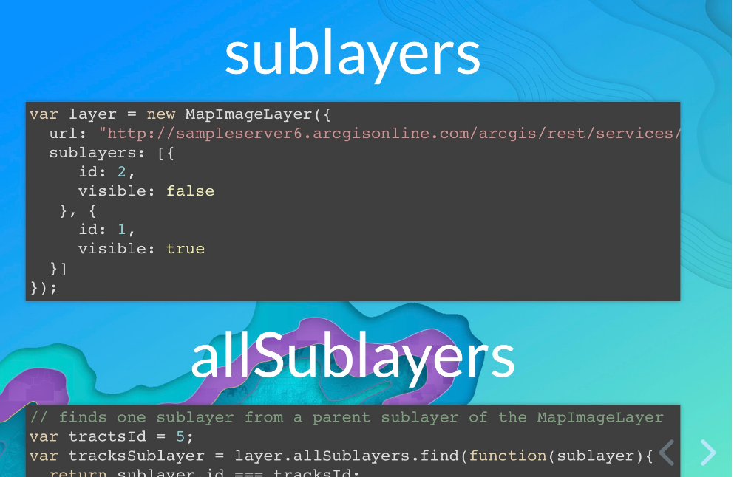

## Canvas-Flowmap-Layer

<https://github.com/sarahbellum/Canvas-Flowmap-Layer> [Demos](https://sarahbellum.github.io/Canvas-Flowmap-Layer/demos/comparison/)

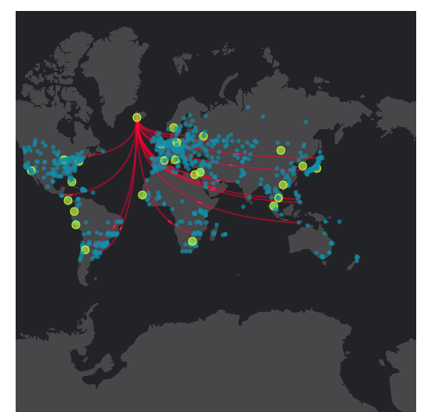

## GeometyEngine

<https://github.com/ekenes/conferences/tree/master/ds-2018/geometry-engine>

<https://github.com/ekenes/esri-js-samples>

Understanding Geodesic Buffering

<http://www.esri.com/news/arcuser/0111/geodesic.html>

# Learn JavaScript API 4.6 Level 0

## Start building an app in 15 minutes.

<https://developers.arcgis.com/labs/browse/>

## Getting-started-web-dev

<https://github.com/hgonzago/DevSummit-presentations/tree/master/Dev-Summit-2018/Getting-started-web-dev>

ArcGIS JavaScript API 4.6

<https://developers.arcgis.com/javascript/latest/sample-code/index.html>

<https://developers.arcgis.com/javascript/latest/api-reference/esri-symbols-WebStyleSymbol.html>

# Learn JavaScript API 4.6 Level 1

## Adding widget shell

<https://github.com/gbochenek/wab-test-example/commit/535d351aab8b76142e7e5280663e38bf426f0623>

Notes: All the related code are located in GoToDevSummit.html and GoToDevSummit.js.

In Widget.html, it is only a container. Still need to call functions from Widget.js, if onOpen(), onClose(), resize() are needed.

Advantage: Easy to move to different environments. Easy to test. Easy to share.

## **Dev-debug-tips**

https://www.youtube.com/watch?v=nVMeu65qnc4

<https://github.com/hgonzago/DevSummit-presentations/tree/master/Dev-Summit-2018/Dev-debug-tips>

**Visual Studio Code (free)**

<https://emmet.io/> snippets

<https://pawelgrzybek.com/snippet-generator/> snippet generator

Browser Extension:

* WhatFont
* JSON Viewer
* JavaScript and CSS Code
* Awesome Autocomplete
* Wappalyzer
* Quick source viewer

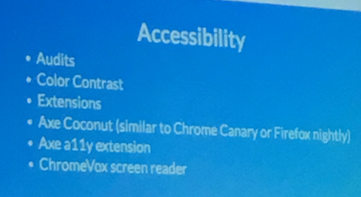

# Learn JavaScript API 4.6 Level 2

## JavaScript Web Optimizer

<https://github.com/lheberlie/web-optimizer-js>

The ArcGIS API for JavaScript Web Optimizer is a web application that generates custom builds of the ArcGIS API for JavaScript. The advantage of using a custom build is that your application downloads and parses only the required JavaScript resources which will make your application load faster.

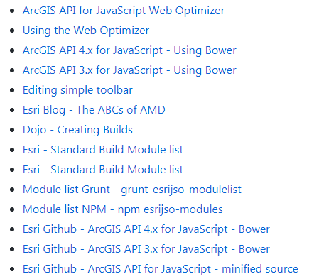

# Style the map website

## Improving Your Web App Through UI/UX Best Practices

<http://patrickarlt.com/dev-summit-2018-talks/ui-ux-best-practices/#/>

<https://github.com/patrickarlt/dev-summit-2018-talks>

## App Design and CSS Styling

<http://slides.com/alaframboise/arcgis-js-css-app-design#/>

Sample codes: <https://github.com/alaframboise/arcgis-js-app-patterns>

## Calcite-maps

<http://slides.com/alaframboise/designing-apps-with-calcite-maps#/>

<https://github.com/Esri/calcite-maps>

<https://esri.github.io/calcite-maps-styler-template/index.html?webmap=default&title=City%20of%20Garland&lat=32.91&lon=-96.64&zoom=11>

## ESRI Leaflet map

* <https://github.com/Esri/esri-leaflet>
* Load much fast than ArcGIS JS API. Not as powerful as ArcGIS JS API.
* this includes Esri [basemaps](http://esri.github.io/esri-leaflet/examples/switching-basemaps.html) and [feature services](http://esri.github.io/esri-leaflet/examples/simple-feature-layer.html), as well as [tiled](http://esri.github.io/esri-leaflet/examples/tile-layer-2.html) map, [dynamic](http://esri.github.io/esri-leaflet/examples/simple-dynamic-map-layer.html) map and [image](http://esri.github.io/esri-leaflet/examples/simple-image-map-layer.html) services.
* Support for [Geocoding](https://github.com/Esri/esri-leaflet-geocoder) services and [Geoprocessing](https://github.com/jgravois/esri-leaflet-gp) services, as well as service

defined [rendering](https://github.com/esri/esri-leaflet-renderers) are available as well (via additional plugins).

## Map Code Example

<http://esri.github.io/quickstart-map-js/index.html>

<https://alaframboise.github.io/arcgis-js-app-patterns/>

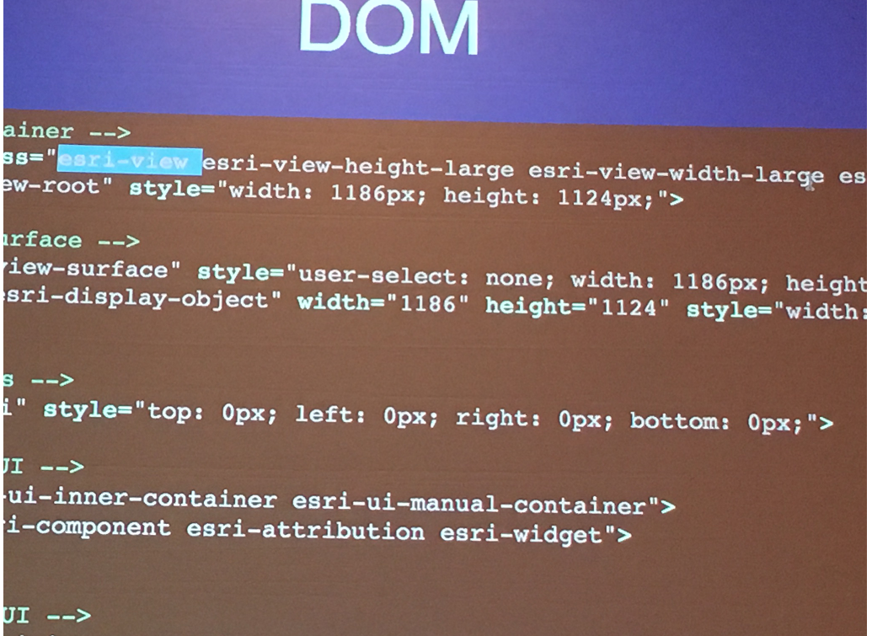

Add title bar

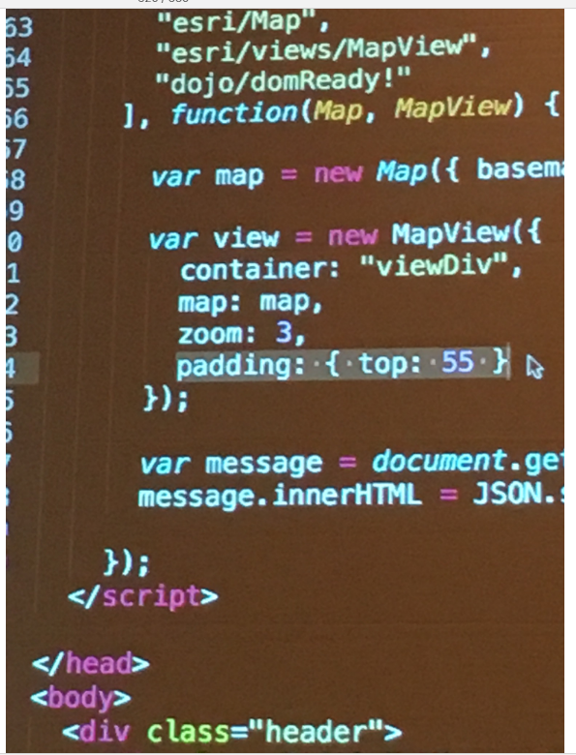

Hide title bar when in small screen device.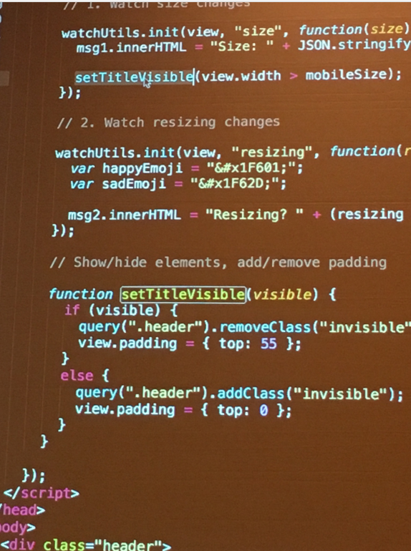

Make the map different for different size screens.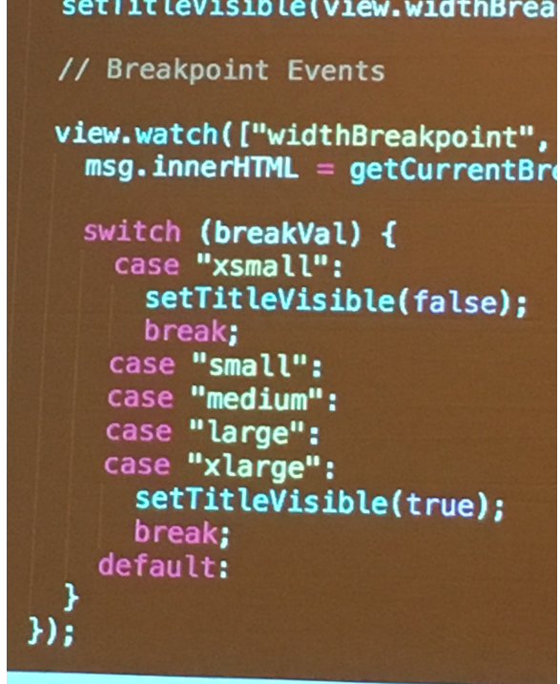

Change color easily

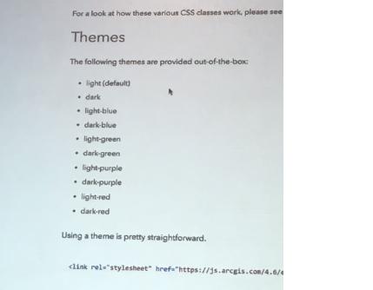

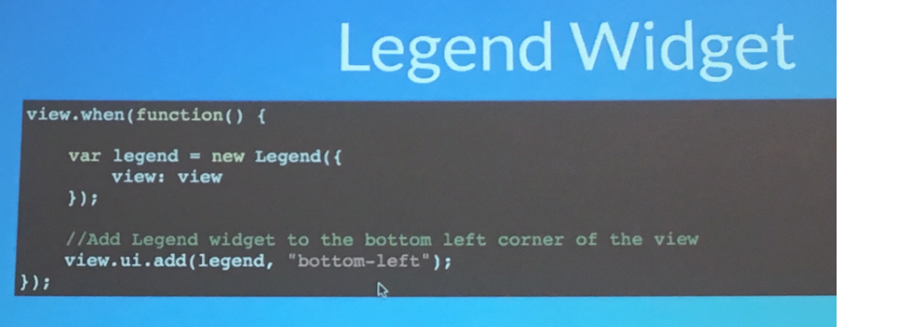

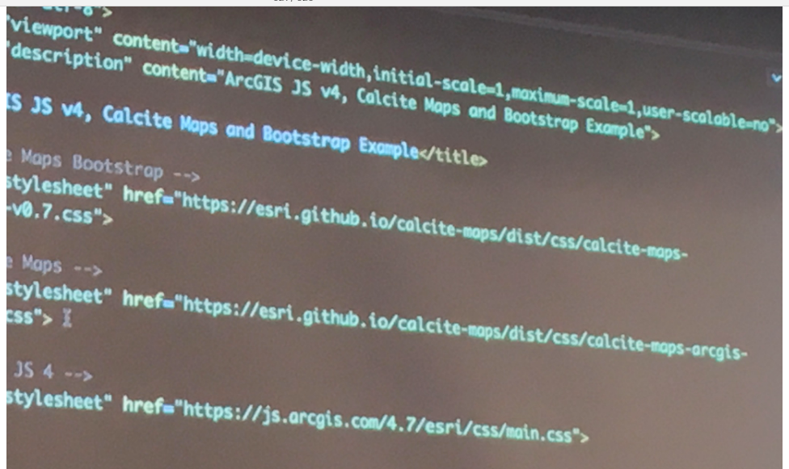 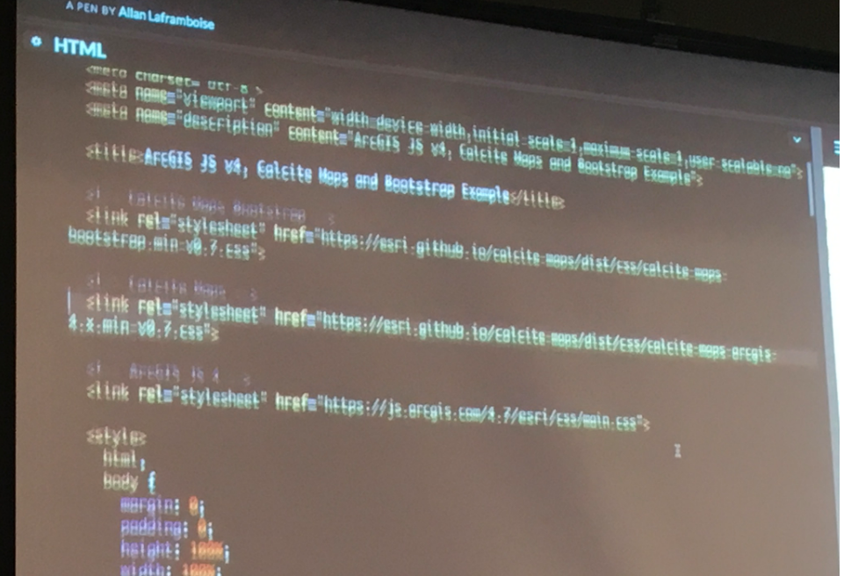 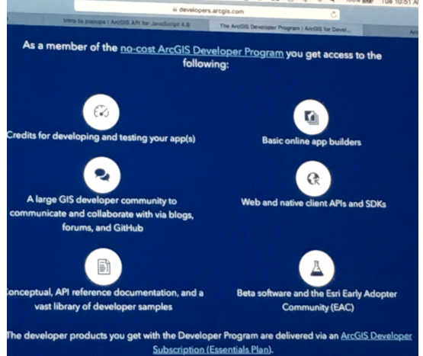 

### **VSCode Tutorials #8 - Code Faster With User Snippets**

<https://www.youtube.com/watch?v=N_QshKsUXO8>

### [**Visual Studio Code Intro & Setup**](https://www.youtube.com/watch?v=fnPhJHN0jTE)

<https://www.youtube.com/watch?v=fnPhJHN0jTE>